Md. Reza Ali Lincon  +8801623649343  rezalincon9@gmail.com | 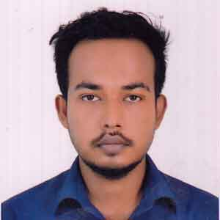
Professional statement

Engineering Graduate with training and experience with academic training at the East West University. Proven skills in project management, organization and research with a background in office administration and organization. Able to provide employers with administrative support and professional communication skills.

East West University
Subject: BSc (Hons) in Information & Communications Engineering
Result: Running

Dania University College
Passing Year: 2014
Subject: HSC
Result: 4.17

Willes Little Flower School & College
Passing Year: 2012
Subject: SSC
Result: 5.00

Training Details

- LICT TOP-UP IT Training for Web Development/Java/etc….
Duration: month, Year to month, Year
● Web Programming using PHP/MySQL
Institute of Information & Technology, University of Dhaka
Duration: (January-April 2016)

Technical skills

- Knowledge of PHP, CSS, XHTML and JavaScript
- Experience with design pattern, frameworks and architecture
- Working knowledge of SQL
- Experience with object-oriented software development methodologies
- Integrating new technologies into web properties

Experience & Projects

Junior Web Developer – East West University Telecommunications club
(February 2017 – Present)
Working on a small team on a variety of development projects and delivering solutions to meet and exceed clients’ briefs.
Duties
- Being first point of call for new and current clients
- Outlining and presenting specifications for all web based requirements
- Hands on development of all projects from genesis to delivery
Projects
- Project Name:
Link:
- Project Name:
Link:
Personal Details
Name | Md. Reza Ali Lincon
Father’s Name | Md. Liaquat Ali
Mother’s Name | Mrs. Rozy Ali
Present Address | 1259 Mohammad bag, Kadamtali, Dhaka
Permanent Address | 1259 Mohammad bag, Kadamtali, Dhaka
Nationality | Bangladeshi

References
Mr. Sarwar Jahan
Assistance Professor
Department of Electronics and Communications Engineering
East West University
E-mail: sjahan@ewubd.edu

